PPY5004 Professional Placement Year

Scanmetals UK Ltd

Work Logbook
Name: Kacper Popis
Student ID: 23161791

Contents
Critical Summary 5
Roles & Responsibilities 5
Evaluation of the Placement Experience 6
Critical Reflection 7
Weekly Entries 8
August 2025 8
Week 34 (18/08/25) 8
Week 35 (25/08/25) 8
September 2025 9
Week 36 (01/09/25) 9
Week 37 (08/09/25) 10
Week 38 (15/09/25) 10
Week 39 (22/09/25) 10
Week 40 (29/09/25) 10
October 2025 11
Week 41 (06/10/25) 11
Week 42 (13/10/25) 11
Week 43 (20/10/25) 12
Week 44 (27/10/25) 12
November 2025 13
Week 45 (03/11/25) 13
Week 46 (10/11/25) 13
Week 47 (17/11/25) 13
Week 48 (24/11/25) 14
December 2025 14
Week 49 (01/12/25) 14
Week 50 (08/12/25) 14
Week 51 (15/12/25) 15
Week 52 (22/12/25) & Week 01 (29/12/25) 15
January 2026 15
Week 02 (05/01/26) 15
Week 03 (12/01/26) 15
Week 04 (19/01/26) 16
Week 05 (26/01/26) 17
February 2026 18
Week 06 (02/02/26) 18
Week 07 (09/02/26) 19
Week 08 (16/02/26) 19
Week 09 (23/02/26) 19
March 2026 20
Week 10 (02/03/26) 20
Week 11 (09/03/26) 20
Week 12 (16/03/26) 21
Week 13 (23/03/26) 21
Week 14 (30/03/26) 22
April 2026 22
Week 15 (07/04/26) 22
Week 16 (13/04/26) 23
Week 17 (20/04/26) 23
Week 18 (27/04/26) 23
May 2026 24
Week 19 (04/05/26) 24
Week 20 (11/05/26) 24
Week 21 (18/05/26) 25
Week 22 (25/05/26) 26
June 2026 26
Week 23 (01/06/26) 26
Week 24 (08/06/26) 27
Week 25 (15/06/26) 27
Week 26 (22/06/26) 27
Week 27 (29/06/26) 28
Milestone Reviews 29
Milestone #1 29
Achievements: 29
Challenges: 29
Learning Achieved: 29
Milestone #2 30
Achievements: 30
Challenges: 30
Learning Achieved: 31
Milestone #3 31
Achievements: 31
Challenges: 32
Learning Achieved: 32

Critical Summary

Roles & Responsibilities
Before the placement started, I was already working with Scanmetals UK as a Document Control Assistant. I approached the company with a placement proposal and got accepted. My placement started on 18/08/25 and will conclude on 14/08/26.
My current role within the organisation is the “Document Control Assistant & IT Administrator / Developer”, the role takes in IT and non-IT related responsibilities and tasks.
This role requires management, maintenance and control over the documentation and flow of information across the various systems used within the organisation. To accomplish my role, I ensure that the documents held within our system are accurate, up to date, stored in proper locations and compliant with standards such as ISO 9001:2015. I ensure the documentation is kept reliable and consistent using my experience with MS Office, EDMS (Electronic Document Management System) and CMMS (Computerised Maintenance Management System) software.
Alongside this, my role also incorporates IT Administration and Development responsibilities, including administration of current in-place systems, hardware auditing, problem solving abilities, software design and development. During my time on placement, there have been various new software that has been acquired, and it was my responsibility to set up those software. Alongside setting software up, I was also developing and programming my own software that interacted with internal systems.
I also assist in introducing and integrating the Learning Management System (Talent LMS) into our workplace by managing the document structure, assembling training courses for various departments of the business, ensuring constant communication between departments about further steps and feeding back directly to the development team of Talent LMS about any bugs.

Evaluation of the Placement Experience
At the start of my placement, my workload started off slowly with assisting the Document Controller with various compliance and document control tasks, and as time went on, and new projects were presented to both me and my line manager, I picked up more tasks and duties. Being supervised by my line manager who has undertaken ISO compliance training (ISO 9001, 14001 & 45001), has given me an alternative pair of eyes to overlook my work and provide critical insight and frameworks to completing tasks such as overlooking SOP creation within the organization, and auditing internal systems to minimise mistakes and ensure effectiveness.
Later on during my placement, my role focused more and more onto various systems that the business utilises, and my task was to optimise workflows, organise folder structure and ensure the correct permissions were distributed around the digital workspace. This was also overseen by my line manager, and he is the one that would audit and control the digital cleanliness, but my work was also assisted by Zentura – the external IT company that manages our digital space across the organization. The company specializes in Microsoft 365, Azure Cloud and device security alongside providing general IT support to the business. Some tasks also required the involvement of contractors that Scanmetals utilises, and my work would also be thoroughly checked by external companies. Slowly my role took over the general IT support that they provided, as majority of issues could be solved in house, rather than involving the IT company. This transition also shifted my focus on creating digital solutions, to help improve current systems, to make it more closely aligned to what the business needs, rather than what software providers offer – as there is never a one-for-all system.
I believe that the transition between work focus was smooth and effective, and the tasks that were being allocated to me both challenged me and definitely expanded my skillset. I knew that I would always have a reliable source of assistance, no matter the task assigned, and my work would always be verified by at least one more person, to ensure its compliant and up to the business’ standards.
I did face some issues in settling in with my work, as the IT field within this business was completely new to me. I learnt a great deal about how Zentura manage our systems, and the security limitations they pose on the network. Because of those limitations, some of my projects were delayed, or couldn’t function properly without their intervention – the Site Induction Website being one of them, as it needed a registered App on Azure to allow for Microsoft Graph API interaction, which could only be done by Zentura as they have the admin privileges. I also learnt, and worked alongside contractors directly, to provide support while they were present on site.

Critical Reflection
I believe that this role has given me a wide range of skills and experience, and provided a different experience of working within a business environment, developing projects with various departments and working with external businesses to complete tasks. I believe this role has fully satisfied the criteria for my placement, I’ve also fulfilled all the criteria that Scanmetals has wanted from me, and for my personal objectives I believe I’ve achieved much more than I was originally anticipated. I mainly wanted to focus on developing my skills as a software developer and I believe that through working with various programming languages (like PHP and C#) has greatly assisted me in setting my foundation within that role.
Alongside programming, I have also done a lot of hands-on work, one of the major accomplishments being connecting the newly acquired office into our main network, this has exposed me to working with switches, VLAN’s, crimping cables and patching sockets into hubs – task that I wouldn’t really be able to complete in a domestic environment – which would greatly benefit me in the future with networking.
Aside from tech related skills gained, I also gained important management skills, as I was assigned to control the stock levels within the server / comms room, to ensure all there is always stock available for users at all times.

Weekly Entries
The weekly entries are updated throughout my time during the placement, and these entries highlight the key tasks allocated and completed by me. It also outlines the skills learnt or fortified throughout my time on this placement. On top of these tasks, I complete tasks for Document Control (which can consist of reviewing documents and finalising Standard Operating Procedures), and routinely checking our internal IT Issue Ticketing System (that I have created) and resolving these issues as soon as possible. All Document Control tasks & IT Tickets are not going to be outlined for every entry as every week consists of solving tickets and document control tasks. If any major tickets arise or I get assigned any major tasks (like audits), they will be mentioned.
Each week is broken down into the respective week number (as per the year and not placement week) along with the start date of the week.

August 2025

Week 34 (18/08/25)
- Update the internal document register by creating a new lookup column within SharePoint, named it “associated documents”, and allowed for entries within the register to be linked to each other
- Tasked with revamping the entire IT SharePoint page to provide more statistics and display meaningful dashboards that can be accessed easily and directly from the sites home page
- Updated the CCTV Footage Request register, by creating new text columns called “User Exporting Footage”, “Date & Time of Export”, “Purpose of Export”, “Retention Period”, to make the register more compliant and provide better retention control

Week 35 (25/08/25)
- Issue was raised about the TBR (To Be Reviewed) Power BI dashboard, as the formula behind the “Days Remaining” calculated column wasn’t picking up the correct values, and presenting the incorrect time remaining
- Browsed around the internet for a suitable software to create a network topology map. Tried to utilise an IP scanner to list all the devices within then network, and slowly map out what device is connected to what port. This project eventually was put to a stop due to devices being moved around too much, and no proper software to display these devices
- Repossessed all leftover IT equipment from the office that another company (Brookside) previously occupied, into our server room and insert the equipment into our stock system

September 2025

Week 36 (01/09/25)
- Planned locations for new notice boards to be set up around the site for documents to be posted. And I was tasked with creating work orders for the maintenance team to set the notice boards up. Once these notice boards were put up, I had to print and laminate documents and hang them on all the new notice boards and ensured all notice boards replicated the same documents
- Started working on a project for a Scanmetals “one stop” portal for employees to access specific apps, websites and forms from a singular point. The main push for this project was the change in Microsoft Forms no longer allowing links to specific forms to be saved on mobile devices (instead it would only save the link to the Microsoft Forms homepage). This visual draft below was created inside of Figma
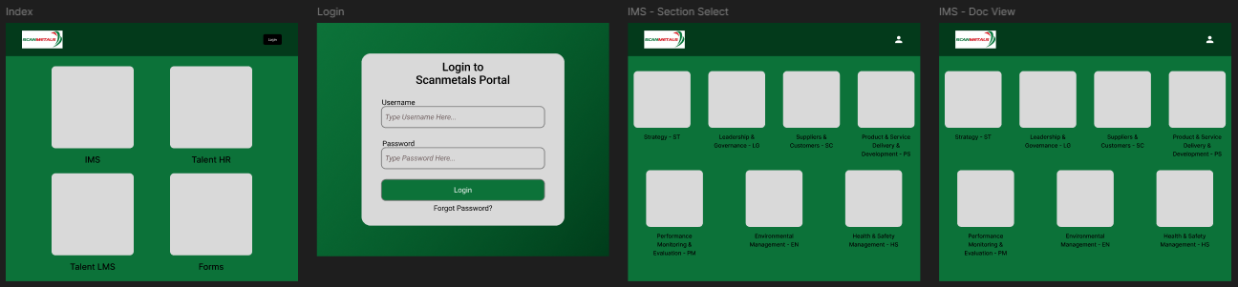
- Contacted one of our current mobile phone service provider, O2, to switch over majority of our numbers from another provider, EE, onto a singular provider. This task span for about a month due to difficulties in communication and requirements from O2 and EE
- Started working on a process for booking out IT consumables on our storage system (ShireSystem). To ensure that the process would work properly, the current stock levels of consumables had to be checked – stock levels were updated according to what is “on the shelf”. All storage locations on ShireSystem were also checked and updated
- Lists of shared logins (both active and inactive) were moved from the previous locations within SharePoint, and placed into the newly created register within the IT section of SharePoint. This new list will be the one central source of shared logins, and all the other previous lists will be retired and access to those lists made no longer available
- Audited ScreenCloud (our remote screen display software) to ensure appropriate and most updated documents are being displayed on the screens. While looking through the software, there were old versions of documents scattered around different folders, the Document Controller was notified, and the documents being displayed on the screens were removed

Week 37 (08/09/25)
- Looked into Document Controller’s TBR (To Be Reviewed) spreadsheet – a list of all documents that are currently in review, but just as an excel spreadsheet. The formatting was improved to make it more user friendly and highlight actual meaningful information like review by dates or the document owners, and not just be an information dump
- Created a python script that generates a “Distribution List” table, which displays all current roles in the organization, by department. This script creates a word document, then creates a table inside it, and populates it based on the information from SharePoint. The table is also stylised in the same way as in the SOP’s, to provide a simple copy & paste

Week 38 (15/09/25)
- Process was set up on Admin Droid (M365 permission monitoring software) to create an alert any time permissions were granted / modified within SharePoint, this alert would then notify the Document Controller
- Created a Power BI Dashboard for the Office Administrator to display in more details where spending is going. I also created a budget comparison between this year and last year

Week 39 (22/09/25)
- Was tasked to service the shared desktop PC’s that are found around the site. This included checking the software installed on the machines, checking for any windows updates and ensuring the device is secured with the latest patches, fully disconnecting the PC’s and cleaning the hardware inside the case – due to the nature of the job, the PCs are found in areas that collect a lot of metal dust (comes from the material we process in the warehouses) which is very harmful to the components themselves as there is a high concentration of metal within the dust, which can potentially cause the components to short circuit. Old desktop PC that was stored (due to a faulty SSD) was planned to be used within a future project, new SSD was ordered and replaced putting the PC in a functional state again.

Week 40 (29/09/25)
- Reviewed our current document system, more specifically how expired documents are treated and how document owners are notified about the expiration of documents. Currently, a flow would run daily and check if documents are expired – if any expired documents are found, an email would get sent out to the Document Controller account directing the user to the document that has expired. I was then asked to enhance this system by also including the document owner within that email. To do so, I had to update our document register to also automatically include the document owners email within the entry of the document – a calculated column decided the value of the email based on the name of document owner provided. The initial flow was updated to then also include the email value of the document owner within the email that gets sent out to the Document Controller
- Updated the current list of cameras (on SharePoint) which didn’t contain much information about the cameras active on site, only a few cameras were listed. Added all cameras on site with their respective IP addresses and NVR’s they are connected to
- Added all tablet devices found on site into our Asset Register (found on SharePoint as a list), storing all information about the device, such as make, model, serial number, etc and where its located and who its assigned to, as a way of tracking ownership
- Tasked to update the Document Control Power BI Dashboard, to include the newly created AI related columns – columns were created to satisfy ISO standards and information needed to be displayed both on documents and within the document entry within the register. The information being fed into the PBI dashboard was updated to include the newly created columns, and new content was created on the dashboard to ensure the data was being read correctly. Information such as “documents with missing AI information” were added to the existing dash to highlight documents with missing data

October 2025

Week 41 (06/10/25)
- Was tasked by my line manager to gain the login credentials for the deactivated windows server found on site. Manager advised that the credentials would be held by Zentura so I had to get in contact with them. The plan for this server was to reactivate it so that I can host my future projects on it. After communicating with Zentura, they were strongly against the idea of reactivating the hardware, and instead suggested to use a Hyper-V host for these projects. The outcome was not what we intended, further planning was necessary in order to weigh out the pros and cons of where to host the projects on

Week 42 (13/10/25)
- Was tasked with ensuring documents move automatically into the “working documents” folder within the appropriate section, when the document goes into its review period. After searching for various solutions, I was unable to create a process for this to move documents from one section to another, due to the limitations of Microsoft Flows and the current setup of our SharePoint
- Was tasked to look into the Health & Safety Power BI Dashboard as information was being displayed incorrectly. Within the dashboard, we display information like “Days since last accident”, and the dashboard wasn’t displaying accurate information. The issue causing incorrect information to be displayed on the dashboard was due to a filter being applied to the card element. There was a filter applied onto the element that excluded the number 0, causing the incorrect information to be displayed if an accident happened on the day. Additionally the formula that calculated the “Days since accident” value was incorrect, as it was looking at the day of the report being submitted, rather than the day that the accident happened, resulting in slight disparity of data. Issues were corrected and dashboard was republished with correct information

Week 43 (20/10/25)
- Scheduled and conducted a meeting with the management team about the progress and status of actions within Talent LMS. Within the meeting we discussed about the progress from the various departments, and asked about any issues that they encountered while using the software. Some minor issues were highlighted as users were still getting adjusted to the new system and the look of it, I guided users on how to navigate around the site
- A meeting was scheduled between Zentura and Scanmetals. The purpose of this meeting was to discuss the current state of company relations, raise any issues we had in terms of the service with Zentura and speak about future improvements both in relation and service. The meeting consisted of Tony Andersen (Director of Operations – Zentura), Lars Viggo Hvolbøll (CIO – Scanmetals), my line manager and me

Week 44 (27/10/25)
- Was tasked with updating the current script that allows users to connect their device to network drives. The plan was to update the current “networkdrive.cmd” file from only adding drives “R:”, “S:”, “W:” and “Y:” to the user’s device, to adding the previously mentioned drives and sending out a notification to the Document Controller that the command has been ran. Ideally this would be possible via Azure, but we do not have access to manage that, so an alternative would be trying to send an email through the mail server. To complete this tasked I looked around sites like Stack Overflow to assist me in updating this file as I myself haven’t worked with “cmd” scripts before, so the syntax and methods were unfamiliar to me. I was unsuccessful in finding a method that would work easily and seamlessly. Reported this to my line manager and he advised to not look into the matter further as this isn’t necessary as this script only gets ran when a user loses access to those drives or has a new device assigned to them – which is rarely
- We have printers around the office area and around the production area of the worksite, my task was to locate these printers, add them to the Asset Register on SharePoint, and ensure all appropriate information is being stored such as make, model, serial number and IP address. This information was then also replicated within ShireSystems – each printer was created as an asset on the system, with all information carried over (from SharePoint). Alongside this, components for those printers would also need to be created within Shire Systems – various colour toner cartridges, waste containers, and any replaceable component for those printers would need be created and have their location saved accordingly, while also ensuring that these components are assigned to the correct printer asset
- Placement Catchup with Joel (BCU)

November 2025

Week 45 (03/11/25)
- At Scanmetals, we utilise a service called “Printix Client”, which is our controller for printers. This service allows any device on the network to print to any printer remotely (both UK and Non-UK network printers). I was tasked with reviewing the naming convention of these printers, as the printer names were outdated or describing the wrong location. Zentura manages the service, so I created a list of new names that the printers should be named as to help better reflect current locations, to clear any confusion
- Reviewed the shared login list on SharePoint and verified with multiple users if the login credentials are up to date or if the service is still in use. Based on the feedback received, a new selection column was created to indicate if the credentials are in use or not

Week 46 (10/11/25)
- Reviewed all the devices (mobile phones, laptops and desktop PC’s) stored within ShireSystems, checking the stock that is displayed within ShireSystems and the Asset Register, checking for any missing devices, checking if devices are assigned to the correct user on ShireSystems, checking if device names are in the proper format on ShireSystems (following the naming convention of “SCAN0000” where “0000” is a randomly generated number).

Week 47 (17/11/25)
- I was tasked with auditing Microsoft Flows. Within our Flows, there is a great number of flows that assist in running the business and some background processes. My task was to track down which flows are in use, which flows aren’t used anymore, which flows the Document Controller is the owner of, and any that are shared to the Document Controller. Initially I started working on a new flow that would list all the flows within the environment, but because I later learnt that the function to list all flows was limited to an account with admin privileges, which I did not have. Due to this limitation, I was unable to complete this task further, and notified my line manager of the issue

Week 48 (24/11/25)
- I was tasked with reviewing the current employee data related Microsoft Flows, and my actions were to verify that the information is coming from the correct Microsoft Form (due to version control requirements, we have multiple versions of documents and forms that information can be collected on), ensure that the information is being processed efficiently and without errors. I also needed to ensure that the correct managers are being automatically emailed
- I was also tasked with reviewing the current register of storing CCTV footage. The aim was to provide more clarity on the steps of working with CCTV footage exports. We aimed to know how long footage was stored for, why it was placed on extended hold (if it was) and if its still on extended hold. To solve this, I created additional columns within the footage request register and suggested new steps to be added to the SOP about handling CCTV footage

December 2025

Week 49 (01/12/25)
- Milestone #1 – Deployed my Digitalised Site Inductions project, within the business. This project is a locally hosted website, that is hosted through the Apache service (by utilizing XAMPP Control Panel) to allow for communication over the network. The project was originally built using HTML and CSS, but due to the requirements of a signature box within the form, languages like JavaScript and PHP had to be utilized to pass data through forms, and generate a signature image. On top of that, the project utilised a package called FPDF which allowed for the program to generate a .pdf file with the user’s information and signature inside it, as if they were filling in the actual document on paper. Upon introducing this project, it completely removed the previously paper-based procedure, and now is available digitally anywhere across the network, making the experience for visitors and 3rd party drivers much easier. Once the program was made available, I was monitoring the system for any issues, and noting down feedback from users about how they are finding the program.

Week 50 (08/12/25)
- I was invited to attend a meeting with Lars Viggo Hvolbøll (CIO – Scanmetals) & my line manager to discuss any issues about Zentura that we are facing. As both me and my line manager were facing slight issues with the support agents from Zentura, we believed that a meeting was necessary to discuss behaviour patterns, and the quality of replies and work from the support agents, and we were greatly dissatisfied with some of their conditions that were placed upon us
- Since I created the IT Ticketing System within our Microsoft Environment, the process for recording IT related issues needed to be updated, previously, any IT related issues would be raised as a category for a Non-Conformity. This process changed and I removed IT as a category from the Non-Conformity Report

Week 51 (15/12/25)
- One of the brands we utilise for CCTV cameras and software is Foscam. I needed to get in touch with them because we were utilizing their cameras without the proper access methods, they offer an app that can be utilized as a singular point of access for all of their brand cameras. The reason why the support team needed to be contacted was that the app didn’t allow for custom grid layouts of camera, which wasn’t ideal, and there wasn’t an option for popout view for these cameras, nor an option for multiple instances of the app being open at once. I tried all troubleshooting that support suggested, and asked for these suggestions to be looked at, but in the end, we had to revert to just accessing the camera feed via the camera’s IP

Week 52 (22/12/25) & Week 01 (29/12/25)
- Christmas Holidays from 25/12/25 to 02/01/26

January 2026

Week 02 (05/01/26)
- The Document Controller raised an issue to me about our Document Register within SharePoint – entries within the register were not being updated properly, and documents were randomly expiring. After investigating SharePoint and Microsoft Flows, the issue seemed to stem from a Flow that was previously disabled, that interacted with all entries in the register. The flow updated a column called “Today’s Date” daily, the register was able to refresh all of its calculated columns. Without this interaction to an entry, the calculated columns would not refresh their data, which is what caused the confusion with documents randomly expiring. This issue / quirk of SharePoint was notified to the Document Controller, and the register since has been displaying information correctly
- Initial meeting with placement tutor (BCU) – meeting held online on Teams

Week 03 (12/01/26)
- I was tasked with working with some of the newly purchased Mini PC’s and worked alongside the maintenance team to ensure the devices are mounted correctly and properly. I was also ensuring that the devices are set up correctly on the network and ensure they are enrolled into the Azure environment
- I was assigned to work alongside a contractor (MTServices) to ensure server was being backed up properly. An engineer was tasked to assist in setting up a backup solution onto our PC’s that host the server for out Access Control System (Net2). I was overseeing and helping with the remote install of the backup software and kept in constant communication with the engineer to ensure that the correct information is being backed up
- I was also tasked by the Maintenance Manager to assist in creating a map of all the electrical board on site. I was given a birds-eye picture of the site, and the various locations of all the electrical boards found the site. My task was to map out all those locations on that picture and make an interactive map. I decided to utilize PowerPoint as my tool to map this out due to the seamless referencing available, allowing users to click on certain locations and it will take them to a slide with an image of the electrical panel, and a brief description. Each slide contained a navigation panel at the bottom
(due to the sites environmental permit, I am unable to provide images of the map itself, only the navigation I created)

Week 04 (19/01/26)
- Scheduled and conducted a meeting with the Maintenance Department in regards to Talent LMS and their progress on the platform. The meeting was attended by the Maintenance Manager, Maintenance Assistant, my line manager and me. During the meeting, we discussed the structure of the learning for the maintenance engineers, due to engineers specializing in specific maintenance tasks, areas and machinery, the courses provided within LMS for their team would need to focus more on those specialised areas, rather than job role itself
- An issue was raised to me about the IT Ticket reporting system. The Microsoft Flow behind failed on a specific ticket submission. Upon investigation, the error that was being thrown was a character overflow. Upon filling in the form behind the IT Ticket Submission, the user entered more than 255 characters into a singular entry box, and MS Flow can only process up to 255 characters from every single entry - this was the cause of the flow breaking. To prevent this from happening in the future, I set a restriction on the Form to accept up to 254 characters on all the text entry fields, ensuring that a character overflow cant happen again
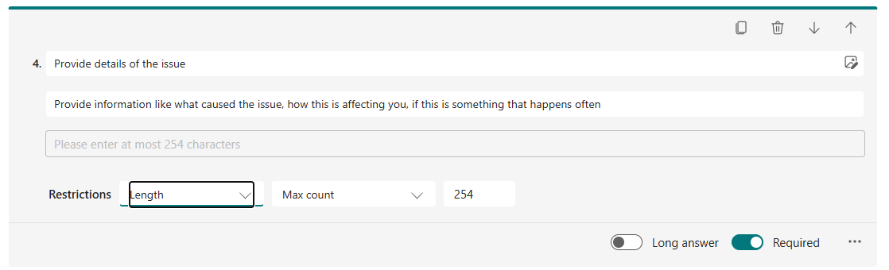
- I was also tasked with holding a meeting with the Production Supervisor and my line manager and discuss about renaming all of the cameras around the site, inside our CCTV system, as the cameras had names that were no longer accurate, some cameras were moved around, and new cameras have been installed since and not renamed. A list was made, that was then agreed upon by all the meeting participants and was then actioned by me
- I was also tasked with locating peripherals (pair of monitors, docking station, laptop and extra cables) necessary to set up a user workspace – checking current IT stock and ordering some spares. Once all parts were located, they were issued to the user and I set up their desk with all devices and ensured they are connected and ready to work

Week 05 (26/01/26)
- The Health, Safety & Environmental Lead asked me to work on a map of all cameras found around the site. The mapping out of the cameras was completed similar to how the electrical board map was done – the only difference being that the cameras were mapped out based on the NVR (Network Video Recorder) that each camera is connected to. Additionally, I created custom icons within the map to help differentiate between the various types of cameras found on site
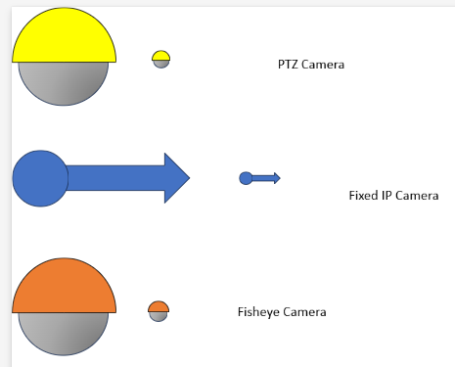
- A faulty device was brought to me by a user, and the issue was that the laptop was running slow and randomly powering off. Upon looking around the device, I ensured all the correct drivers were installed, ensured there are no outstanding critical updates and ensured there is sufficient power going into the device. Once all these checks were completed, the device was benchmarked using “Heaven Benchmark” and no issues were flagged, and no random powering down. The device was given back to the user, and after a day the user came back with the same issue. I looked around the System Information, and noticed that the BIOS installed is for the wrong model of laptop. I downloaded the correct firmware update for the laptop’s model, and installed it. Upon completion I ran driver updates again, and once those were done, gave the device back to the user. Haven’t heard of any more issues since
- Due to the introduction of Talent LMS, we needed a shared windows accounts to access shared laptops for employees to conduct training. I contacted Zentura to set up 3 new shared training users, with limited permissions, to allow for employees to access laptops to complete any assigned training via Talent LMS

February 2026

Week 06 (02/02/26)
- The app “Remote Desktop” was coming to end of support, which is an app the business utilises to access the weighing systems. Upon receiving the notification, I informed Zentura about the notification and received confirmation from them that they are working on implementing a swift changeover from “Remote Desktop” to “Windows App” (a direct replacement for the app). This change over was planned to be rolled out before the end of support for Remote Desktop
- I was asked to assist the Financial Controller and the Document Controller with a finance audit. I was asked to provide screenshots of things like the 2FA used within the business, the current version numbers of the software we utilize, and our stock control process alongside purchase orders in relation to IT
- An issue was raised to me about a faulty ID Card Printer, the printer kept jamming during printing and misaligned the printing. I troubleshooted the printer by ensuring the device was fully updated, inspected the health of the device and monitored it during the entire print cycle. The issue seemed to be with the components of the printer itself, and due to the printer being under warranty, it was returned to the supplier for repairs
- A meeting was scheduled between me and Zentura’s Application & Cloud Specialist (SME), Simon, to discuss my current Site Induction project and potentially look into implementing it as a cloud solution. We discussed costs about hosting the project entirely through Azure / Cloud, but after comparing the costs to hosting it in the cloud and hosting it locally on a backed up device, we decided that for now, the project will be hosted locally
- An issue was raised to me about users not being able to refresh spreadsheets because they are unable to access the database behind the spreadsheet when working from home. The issue seemed to be caused from the database only being accessible through the workplace network. I suggested to the user to utilise the Windows App when working from home, to access their digital workspace, which has all the correct connection paths available to refresh all spreadsheets.

Week 07 (09/02/26)
- Assisted in diagnosing an issue that has affected the workplace – Caller ID Spoofing – users were receiving phone calls from numbers within our organisation but the user was not actually making the calls. All employees with work handsets were notified about this issue, and were advised to be extremely careful about sharing information when making phone calls
- I worked alongside the maintenance team to set up a wall mounted display in front of the office’s boardroom. This display was used to show current room availability, scheduled use, and allow for users to book the room directly using the display

Week 08 (16/02/26)
- I was informed that we are acquiring an office building (was previously occupied by a company that shared the site with Scanmetals) and it was planned to repurpose the office space into an area usable by Scanmetals employees. My role in the early stages was to look into the hardware and any devices left behind, to see if any of it can be repurposed. Additionally, I inspected the network infrastructure and assessed that it is a job that I can handle to reconnect the office and ensure its on the main work network. I proposed the idea to my line manager and we looked into planning how to approach this project in-line with other preparations for the new office

Week 09 (23/02/26)
- I was tasked with setting up remote desktop connection access to all shared and headless desktops. To accomplish this, I needed to access all these devices in person, and enable the setting “Remote Desktop” on all the devices. Once the setting was enabled,
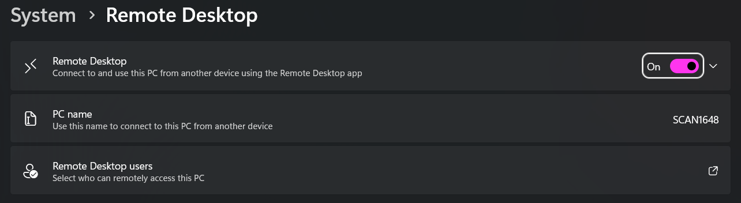
I made sure to test that everything works as intended, by using the Remote Desktop Connection app and was successfully able to connect to all devices remotely. I ensured to save these predefined connections within SharePoint as a way of providing a shortcut to connecting to these devices

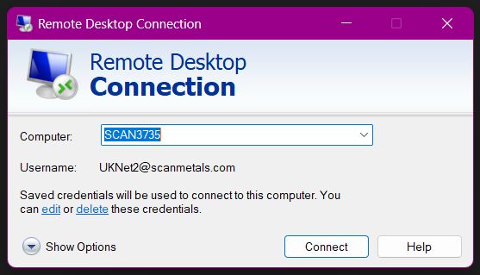
The reason why these connections had to be set up, was due to Zentura moving away from having us utilise Datto RMM for remote connections to devices. Our access to the RMM (Remote Monitoring and Management) system was removed as it was only a trial, and this would be our alternative
- Milestone #2 – After planning the process last week, the approach was for me to set up the networking within the new office, and ensure that all rooms have a means of accessing the network, and to organise the network cabinet within the office. The works were conducted over the next 2 weeks. The works were slightly delayed as we had multiple contractors over working within the same building, meaning that sometimes areas were inaccessible resulting in me having to wait with proceeding with my works

March 2026

Week 10 (02/03/26)
- Renovating the new office still was in progress, but during this week I had a little downtime away from working in the new office as walls were being demolished, furniture was being built and the rooms were undergoing a chemical deep clean. During this time, I ensured to look into purchasing new peripherals for the users that are to be moved over into the new office – new monitors, high powered docking stations, laptop stands and multi-function extension leads. These peripherals were agreed upon by my line manager, the purchase order proposed to upper management, and approved

Week 11 (09/03/26)
- I continued my works over at the new building when I had time away from my usual duties. This week is when my works over at the new building were coming to a completion (at least for the networking side of things). A new switch was installed and configured to accommodate for our VLANs to allow WiFi access within the building, while also having the option for ethernet. I ensured that all cables were tucked away out of sight as much as possible, ensured that all the connections from the sockets to the hub were terminated properly and cleanly. Once all connections were made, all sockets were tested, cables properly labelled, and everything annotated to ensure clarity. Additionally, a contractor from MT Services was called out to assess my work. The engineer inspected my work and confirmed that all the work conducted is done professionally
- We also purchased new Logitech meeting cameras (Logitech Meetups) and I was in charge of creating the digital environment that comes with these cameras. I needed to create an account within “Logitech Sync”, a platform that directly integrates with the Meetup cameras that we purchased. We also have an older version of those cameras on site already and its in use, but was never enrolled within the digital environment. I prepared all rooms in advance and connected the boardroom to the camera that was already in use (as that is where the camera was located)
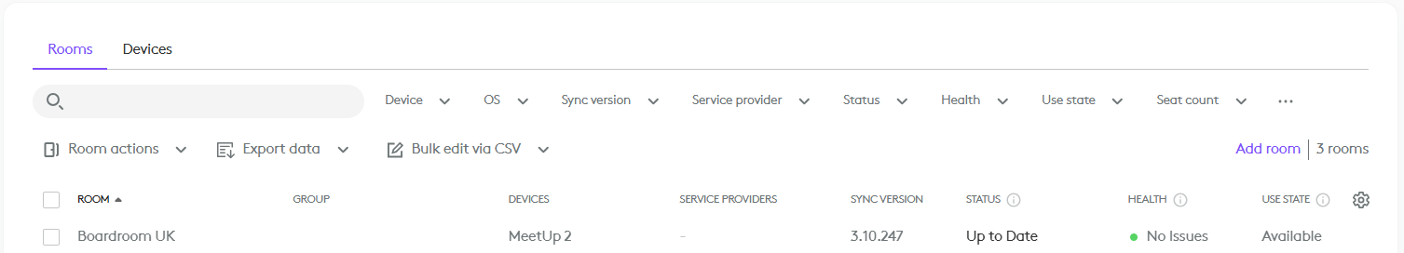

Week 12 (16/03/26)
- Once the new office had all the desks and other furniture fully completed, I was able to carry on out my works and set up all the workspaces for employees within the new office. In total 7 desks were full set up, with a pair of monitors, docking stations, extension leads, additional cables and all these devices were clearly labelled with stickers of their unique SCAN numbers. These devices were then assigned to the building, ready to be reassigned to the relative users once users were ready to move in

Week 13 (23/03/26)
- This week my attention was on Talent LMS and implementing “learning paths” within the site. The purpose of these learning paths is to group courses into these training packages, that can then be rolled out to employees to show their learning progress in a more clear way. I created multiple learning paths, both general and more department specialised training packages that managers can utilise and alter. The structure for learning within each department was outlined in previous meetings, all I was to do was follow the structure provided, and replicate that structure within Talent LMS
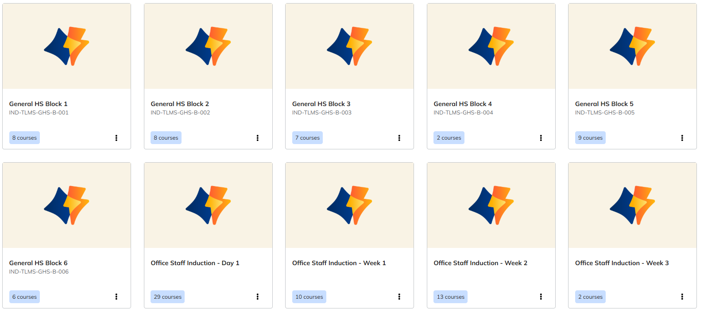

Week 14 (30/03/26)
- This week my focus was mostly on assisting users and moving them into the new office, ensuring there is a seamless change over from the old to new office. I connected each user myself and monitored them for the week, looking out for any issues or difficulties they may face. The main issue that seemed to be present, was cables running along the sides of the desk / floor. I ordered cable organisers and installed them to prevent any trip hazards or any devices getting damaged from accidental pulling on cables
- I also was instructed to get in contact with SCG (Southern Communications Group – our landline provider) to allow for users with landline devices, to have short / quick dials to employees with work mobile phones. To ensure this would work, I provided the support consultant a list of employee names, numbers and short dial codes that would need to be added to our landline phonebook – there is a portal for us to manage our landlines, but SCG has advised against accessing it without the proper training, as changes can not be undone

April 2026

Week 15 (07/04/26)
- I assisted with planning of further improvements for the new office, as everything was already in place and working, but there could be improvements made, in terms of cable management like visible cables into trunking and general re-organization of the office, as some users preferred their desk setup differently
- I schedules a meeting with Lars Viggo Hvolbøll (CIO – Scanmetals) about the usage of CodeTwo. CodeTwo is a system that we use to manage our email signatures. Originally, the only users that had access to this system was the CTO and Zentura, and I raised this point during the meeting, that for us (in the UK) to make a change to our signatures, we would need to create a ticket with Zentura, or contact the CTO directly, when this could be something that could be done within minutes if we had access to it. The CTO agreed, and permissions were issued to the Document Control and me to manage the service

Week 16 (13/04/26)
- An issue was raised about the published Site Induction site being inaccessible / unreachable. Upon confirming that the site was still unreachable, I had to investigate the device that the site is hosted from. Upon inspecting the device’s Event Viewer, it was powered down, and restarted due to a windows update. I logged into the Hyper-V server, then went to restart the Apache service through XAMPP and confirmed that the site is back up and running. I then contacted the user that reported the site being down and prompted them to refresh it – user confirmed its accessible again. To prevent this from happening in the future, the Hyper-V service was set to restart whenever it goes down, and inside the VM, XAMPP was set to automatically boot when powered on and to automatically start the Apache service

Week 17 (20/04/26)
- I was asked to set up casting to the Smart TV’s found around the offices, to allow for users to cast their device directly to the TV, without a need for a physical cable connection. I enabled the “AnyCast” feature on all the TV’s and renamed them to an appropriate name relative to their location. Tested the TV’s with multiple devices and multiple users to assess functionality and feasibility, and all the feedback was positive, only a slight delay in inputs, but that is to be expected from screen casting. Users were briefed out on how to access “AnyCast” feature on the TV’s
- I was invited to attend and contribute to a meeting with Lars Viggo Hvolbøll (CIO – Scanmetals) and General Manager to discuss a new internal communication app that will be used as an internal communication platform. During the meeting I was questioned about how we store our employees information, where it is, shared it with the CTO and described how we process employee data and how it enters the employee list. They plan to integrate all employees from all sites into this platform, to have a singular source of truth while also splitting the site (UK users only have access to UK data, etc)

Week 18 (27/04/26)
- I was tasked to setup a new conference suite within the Production Manager’s new office. A smart TV was mounted within the office, one of the new Logitech Meetup 2 Cameras, and a Mini PC. The Mini PC was pre-configured prior to the setup by me so that the user can utilise the PC as a standalone desktop, but could also cast to the PC if there is a need for it (using the “Wireless Display” windows app). The TV was also set up to allow for wireless casting, by enabling the “AnyCast” feature on the TV, and then briefing out the user on how to cast. Additionally, the Logitech camera was also enrolled into the Logitech Sync portal, and updated to the latest firmware
- My line manager asked me to continue works on my published Induction Site to implement a way of revising the document that gets generated by the site. Currently the site uses screenshots from the original document, and generates the content within the PDF using the screenshots and then inserting the user data at the end – the suggestion was to allow for the document used as a template to be a replaceable document, that can be overridden with newer versions. To ensure this is possible, I left the published version running as is, and in the meantime, I can work on a separate version on my own desktop, without interrupting what is currently live

May 2026

Week 19 (04/05/26)
- Annual Leave for the entire week

Week 20 (11/05/26)
- During the time that the Site Induction project has been live, I’ve been asking and receiving feedback from all that have had the chance to use it (both employees and visitors). One of the most common reply from the end users was that “there should be a confirmation pop up on the screen once the form has been completed”. Due to the amount of times this has came up as feedback, I mentioned this to my line manager, and discussed about how I can include this into the project, and that it can be release alongside the additional changes mentioned two weeks ago
- I was invited to attend a meeting with Office Administrator about the implementation and viability of a new software that we have been trialling called Talent HR (a partner software from the company that provides us with Talent LMS). During the meeting, it was also discussed about potential ways of enabling our current access control system (Net2) to interact with Talent HR system, as users are able to clock in via the swipe of a card, and ideally we would want users to automatically be clocked in and out using that same swipe of a card. I mentioned that I would need to analyse the two systems, see their API capabilities and see what would need to be done to ensure communication between the two
- I also looked into adding a uniform way of utilising document templates across all SharePoint document libraries – but due to the amount of libraries that we have, the method of adding a template into the “create or upload” box for each library would take up too much time for it to be viable. I instead looked into a more efficient method of implementing this into our digital environment using M365 Office

Week 21 (18/05/26)
- A DELL engineer was called out onto site to assist with an ongoing issue with a device, as the user kept saying the device randomly would power off. upon the initial ticket submission, I inspected the device and ensured all updates were completed, no driver issues found, the only error that was flagging up was on Event Viewer – a thermal error saying the threshold for temperature was 40°C, which should never be the threshold. I contacted DELL support to try to sort out this issue, and tried all their troubleshooting steps, which were similar to the troubleshooting I conducted. Eventually upon device log inspection, they issued an engineer to come out and replace the motherboard on the device. Once the engineer arrived, I was assisting the DELL engineer with replacement and works on the laptop. Ever since the motherboard replacement, the device seemed to be working fine
- I continued working on the new features for the Site Induction, and also started working on a system that bridges Talent HR and our access system. I looked into API compatibilities for Talent HR and Net2. Talent HR offers REST API as method of interacting with their system, and Net2 did offer an API, but no longer supports giving out API keys to commercial users. Due to this limitation, I tried to interact with the database directly, completely bypassing the need for an API, but I was only partially successful. I located the database instance of the MS SQL database but I wasn’t able to interact with it at all without the correct credentials. I asked my line manager for any credentials that could possibly be the correct ones but it was to no success, so my only option was to contact Net2 directly. After contacting them, I was given read only credentials that could access the database. To troubleshoot the connection, I used an app called DBeaver to connect and see what information is made available to me. As for Talent HR, they offer an API, but, the API for time tracking (the module that is responsible for clocking in and out) is made available end of the month, so that was placed on hold until them
- Upon doing further research into the M365 Suite, I noticed a feature for organisation templates, I explored this option and found that with this feature we are able to publish document templates directly to the suite, without the need of distributing templates via SharePoint. I suggested this feature to be utilised within M365 Office to the CIO – utilisation of the organisation templates within the Office suite, to help centralise and streamline the document creation and control process. This suggestion then got approved and Zentura was tasked with enabling this feature and making it accessible for all sections of the business
- After interacting with various business’ ticketing systems, I thought that our current one could do with an upgrade, and the main focus of this upgrade was the end user. Currently the end user submits a ticket via a form, and that’s it, no other interaction. Compared to other businesses, the end user would get an update from the support technician based on any changes, so I implemented something similar. When a change is made to any properties of an IT Ticket, the end user is also notified – when I add comments onto the ticket, the end user also receives an email about the updated comments, if the ticket gets closed, the user also receives an email about the closure. To make this possible I updated the form behind the IT Tickets to include the end user’s email, and updated the flow behind the process to send emails to the user of any changes to the ticket

Week 22 (25/05/26)
- Annual Leave (Bank Holiday)
- I was notified of the organisational templates feature being implement by Zentura. Now that this has been made available to me, I made sure to look through our entire IMS and check for templates, and converted these documents into their template counterparts (.docx → .dotx). Users are now able to create new documents directly through Word, PowerPoint and Excel
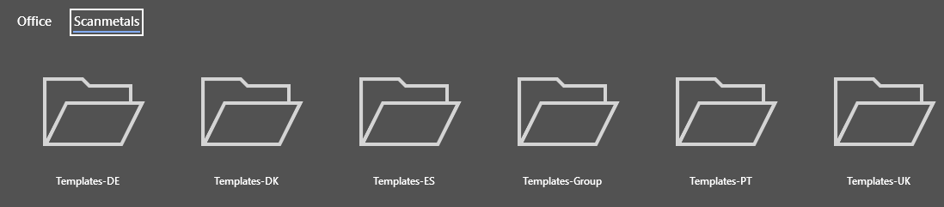
- When I had time, I continued works on the Site Induction project. I managed to developed a JSON configuration file that will store default values that can be utilised when generating the PDF. This config file can be modified through a newly created page, making the site more future-proof as documents within the business are modified / reviewed annually, therefore by implementing this, it will streamline the process as certain values can be updated within the config file, rather than needing to alter the source code

June 2026

Week 23 (01/06/26)
- A network outage cause ~50% of our devices and cameras to go down, resulting in issues with our daily operations, as products were not able to be weighted properly, users not able to access the internet and CCTV not being recorded. To solve the issue we had a contractor come out and assist us with fixing the issue, and it seemed like the issue was with a main switch that caused devices to stop connecting. The switch was restarted and devices were able to connect to the internet as previously
- I was tasked to start on preparing our IMS for an external audit. To prepare for the audit I needed to do the following:
  - Review 700+ documents within our current IMS
  - Ensuring documents are presenting the correct information
  - Ensuring documents are found within the correct locations (folders & systems)
  - Full review of document libraries
This task spanned until next week

Week 24 (08/06/26)
- I started working on a Power BI Dashboard for the Assistant Production Manager, as they asked me to create a dashboard with more visuals compared to what Talent LMS offers, because there is little to no modification of dashboards within the site, and the data cant be manipulated or drilled down in any way. I tried integrating the data into Power BI via an API source, but the API offered very limited data. I got in contact with Talent LMS support, to query their API and their reporting, and was told that the software is still in development, and that more advanced reporting will come in the future

Week 25 (15/06/26)
- I was tasked by my line manager to create an automatic email that gets sent out to document owners, to inform them about documents that are in review. To do this I created a new Flow that reads through the active documents within our document library, and sends an office-wide email to document owners about the which documents are in review, and the amount of days remaining until they expire
- Held a meeting with Office Administrator and Document Controller to plan out the implementation stages of Talent HR – how we plan to roll out this software to staff. It was decided that senior management first, then slowly implement other employees into the software
- Due to the purpose of this seamless clocking-in-and-out project, the framework for the project had to be changed. Originally, I was planning to create a PHP script that would run every few seconds that would clock users in and out based on the information from the database. But this option seemed very inefficient, instead, I started working on a C# project, using .NET. I believed that a Worker Service would be the ideal project template for this as this could run in the background of a singular device, and could be stopped, restarted very easily

Week 26 (22/06/26)
- Milestone #3 - Continued developing the Worker Service to specifically pull only “clock-in” and “clock-out” entries from the server, and only pull the most recent information (only grabs entries relative to today’s date), anything else isn’t processed nor stored. I also managed to include the API from Talent HR to allow employees to clock in within Talent HR purely by scanning their ID card. I tested the service by running it locally on my device, swiped my card on the “clock-in” scanner, and checked the Talent HR app and I was clocked in. I repeated the same with clocking out, and I was clocked out within Talent HR. This was then later demonstrated to the Office Administrator and my line manager, they also tested it and it worked for them
- I also finished writing up a Talent LMS handbook. The purpose of this handbook is to describe basic functionality for the entire portal, for all user types. This handbook is to act as a singular point of reference for “how do I do xyz…”. This handbook once finalised by my line manager, will be made available to all employees to familiarize themselves more with the software

Week 27 (29/06/26)
- The Worker Service has been running locally on my device for a few days, and is constantly logging information. I need to ensure that this program is build ready, and to do that I will need to ensure that there is no bugs or issues present before publishing this onto a host device. The logging of information will need to be improved to be more clear as currently any issues are listed as long strings of objects and file paths, compared to what it should be – simple and concise information
- We also purchased a new QMS (Quality Management Software) software that is to replace SharePoint for document control, this new software is to ideally integrate the functionality of SharePoint and Microsoft Flows into one singular system. The team behind the new software got in contact with us notifying us about the stages of guided implementation, and that this implementation process will take around 8 - 12 weeks, and will start from next week. Meetings will be held with the implementation team, my line manager and me to get this software up and running

Milestone Reviews

Milestone #1
Deploying this project into the business environment was a major leap in my time and efforts within Scanmetals, as I was able to create a software that replaces an entire paper based process for the business. Not only is it more efficient and quicker than doing it paper based, but also is more sustainable as its removing the need for printing on paper, just to scan the same document and store it digitally.

Achievements:
- Users are able to be inducted anywhere on site as long as they have access to the network. Due to us taking on a new office, visitors can be inducted on site straight away, without the need of waiting or multiple copies to be printed out, making things more efficient
- The digitalised method of inducting employees has been incorporated into our SOP’s and has proven effective on our weighing bridge (for drivers) and within the office for any visitors that come on site
- Utilising Git and GitHub as a way of version control and a way of tracking releases for the project. Working with git has also allowed me to fully explore branching code, releasing software and tracking changes made to files

Challenges:
I have never had the opportunity to work with the Graph API so working with Azure to register an app, ensure it has the appropriate connection permissions and interacting with Outlook through the API are completely new experiences to me. And due to it being new, I was very much unsure on how to approach certain tasks, and the lack of internal support for IT related matters (as I was the IT support) proved to be a challenge to me. But under guidance from my line manager with planning my project out, and contacting Zentura with assistance in setting up my Azure app I was able to confidently configure everything and focus on troubleshooting any errors with programming by looking at Stack Overflow for people with similar issues

Learning Achieved:
I have gained valuable knowledge while working on this project as I have been programming with languages like PHP and JavaScript, which I used in the past previously and within the university, and have been able to test my knowledge by building this project and applying new knowledge as the project progresses. Additionally, this project has assisted with my team working skills, which are crucial in a business environment, as throughout the project I needed to interact various people (like Zentura or end users) to ensure that my project is working correctly with the API, ensuring that the software is working as intended, and applying feedback from users – this helps a great deal as a very common approach to software development is the agile method which constantly cycles between planning, developing and testing over and over again

Milestone #2
Rewiring a network cabinet and reconnecting a previously abandoned office building I believe is something that can also greatly help me with my knowledge and career progression. As a software engineer I work solely on the computer and creating something by programming, but as a network engineer, you interact with physical devices and create that connection to end users. By offering myself to complete this task, I was able to complete networking tasks, like reconnecting switches, repatching sockets and working with VLANs within a business environment. On top of the networking, I was in charge of finding and purchasing equipment for the new office and setting users up in their workspaces

Achievements:
- Successfully repatched a set of 20+ sockets into a patch panel and connected these sockets directly into a newly reconfigured managed switch to allow for devices to connect to the main network from another building
- Mounted and reorganized a network cabinet from scratch with all components – crimping cables, connecting switches to patch panels, labelling physical components to help future proof any future works / repairs
- My work was successfully assessed by an external company that specialises in networking, and was very satisfied with the results of my work

Challenges:
No one on site specialises in networking, therefore there wasn’t much support being provided to me in my works, which could have sped up the task to be finished much faster, as I was still learning on how to do tasks like patching cables into a patch panel, as I was working on this I was constantly ensuring that my work be checked by my line manager to ensure that everything was done correctly. Additionally, once all work was deemed completed by my line manager, a contractor was called out to inspect the work, to assess if everything is connected properly. Another challenge faced was that other works were being done around the building while I was assigned this task had caused major problems and hurdles in completing this project. As the space was limited there was days where I would not be able to access the office, and a lot of work was to be done. To help achieve a reasonable completion date, I ensured to communicate clearly with the contractors and work alongside them to have as little discrepancies in time frames as much as possible

Learning Achieved:
I learnt how VLANs work and how they can be managed using managed switches, as VLANs are something I have never worked with previously, only learnt about what they are, but never seen them used within a professional environment. Additionally, setting up a network cabinet from scratch and its components was a new experience to me, although I knew what sort of components would be in one, I have never been through the process of installing each component one by one connecting components to each other. One of the major tasks was connecting the patch panel, this requires a specific patching tool, that cuts and inserts cables into the back of a patch panel, this was a tool that I have never worked with, and was more than willing to learn to use it properly, and connect cables neatly and properly into it
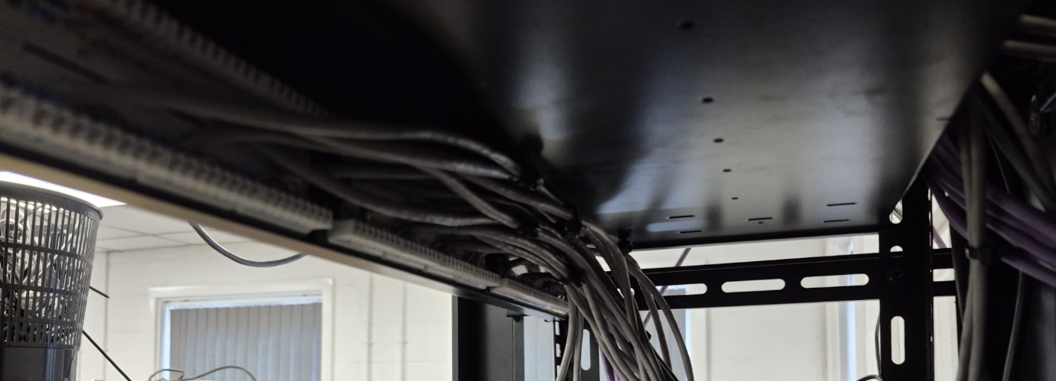

Milestone #3
Developing a software that acts as a bridge between two types of software is a new experience for me. The application itself was originally meant to be a simple script that gets executed, but eventually got turned into an entire service that can run on a device, restart itself automatically, account for any downtime, process information swiftly and most importantly, it can connect to two different systems and pass information from one to another, enhancing the user experience for all employees by making a single method of clocking in, compared to the previous multiple clock in methods.

Achievements:
- Successfully connecting the worker service to interact with two systems individually, then later on once all the correct data has been processed, allowing the data from Net2 to interact with Talent HR’s API
- Users being able to clock into their payroll software by simply swiping a card is a major leap in usability as decreases the interaction needed from the user, and provides a more confident way of ensuring employees are doing their correct hours
- Git and GitHub was also utilised within this project. And using it on a previous project definitely assisted with setting up new projects quickly and synchronising repositories to local folders them without issues

Challenges:
Talent HR is a new software and is very much in development. And because of this, bugs are going to happen. And during my time developing this worker service, I was having issues using the API from Talent HR, as I would get a HTTP error code 500 when calling some methods – 500 code indicates Internal Server Error. To solve this I swiftly got in contact with Talent HR support and worked together to find a fix to this issue. Once my assistance helped pinpoint what was causing the issue the support team fixed the issue and I was able to carry on working on my project. Another issue while developing this project was the limitations of Net2’s API and that it is completely not available anymore to consumers. Although that method of access to data was not accessible, I managed to find a work around by accessing the database directly via a read-only login. If not for this workaround this project would have never been able to be completed.

Learning Achieved:
This project has strengthened my knowledge of programming with C# as this is a language that I haven’t used in quite some time, so it took a few days to get back into the proper syntax of utilising this language. But this project has also shown me how to apply critical thinking to projects as without taking time to assess the situation and assessing the limitations as they popped up during development, then this project would not have came to fruition. I also believe that working inside the .NET environment will also benefit me greatly as a large amount of applications and software utilise the .NET framework, and by working with it I can accustom myself to the framework and become more comfortable when working with it in the future.

